Test Case: tc006_SPX_Dev5_Crear_Requisicion_Spot_Tipo_Cobro_Proyect_Urgent
Step 1 - Enter username and password and click to button Enter: Credentials Entered
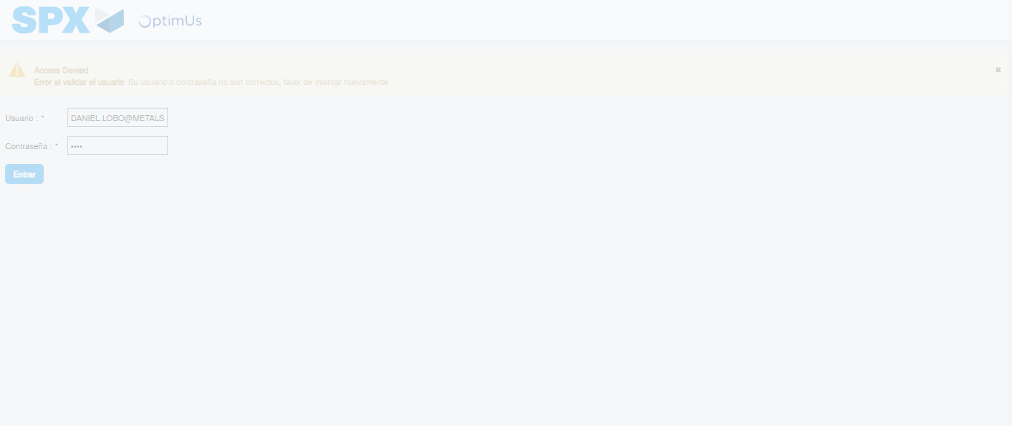Image file-name: QC_Testing-tc006_SPX_Dev5_Crear_Requisicion_Spot_Tipo_Cobro_Proyect_Urgent-1784214792621

Step 2 - Select to UEN and Access to Spot Buy Requisitions : UEN Correctly selected and Correct access
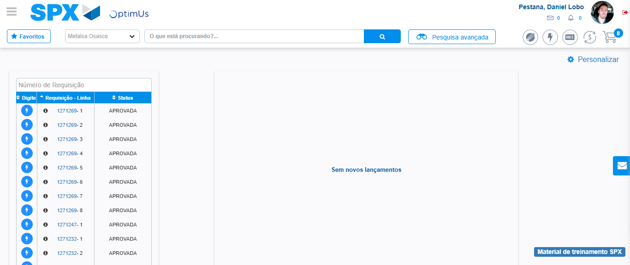Image file-name: QC_Testing-tc006_SPX_Dev5_Crear_Requisicion_Spot_Tipo_Cobro_Proyect_Urgent-1784214818453

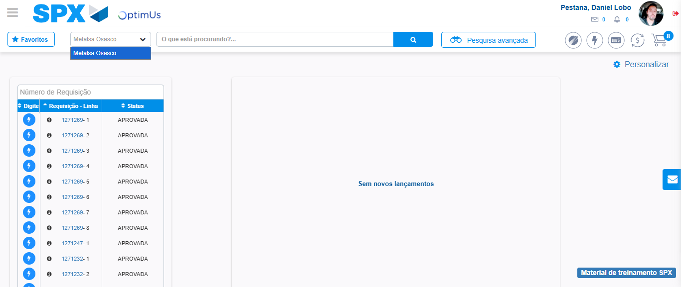Image file-name: QC_Testing-tc006_SPX_Dev5_Crear_Requisicion_Spot_Tipo_Cobro_Proyect_Urgent-1784214821145

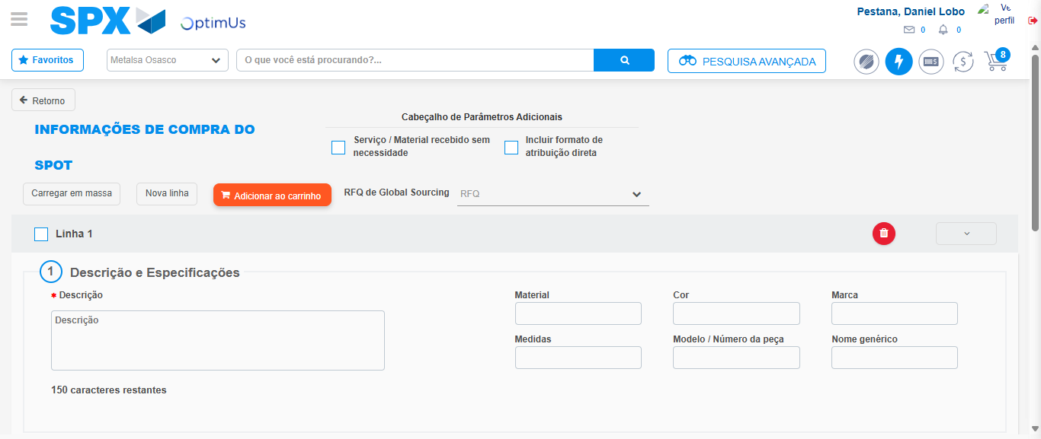Image file-name: QC_Testing-tc006_SPX_Dev5_Crear_Requisicion_Spot_Tipo_Cobro_Proyect_Urgent-1784214843097

Step 3 - Data Capture Spot Buy Requisition: Data captured correctly
Image file-name: QC_Testing-tc006_SPX_Dev5_Crear_Requisicion_Spot_Tipo_Cobro_Proyect_Urgent-1784214843441

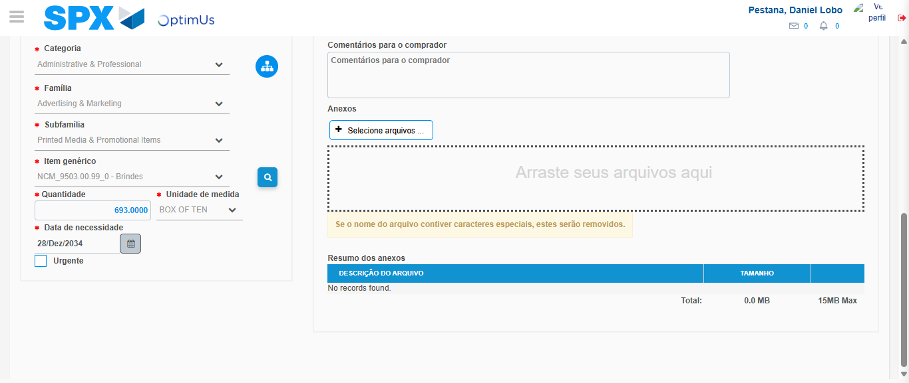Image file-name: QC_Testing-tc006_SPX_Dev5_Crear_Requisicion_Spot_Tipo_Cobro_Proyect_Urgent-1784214856602

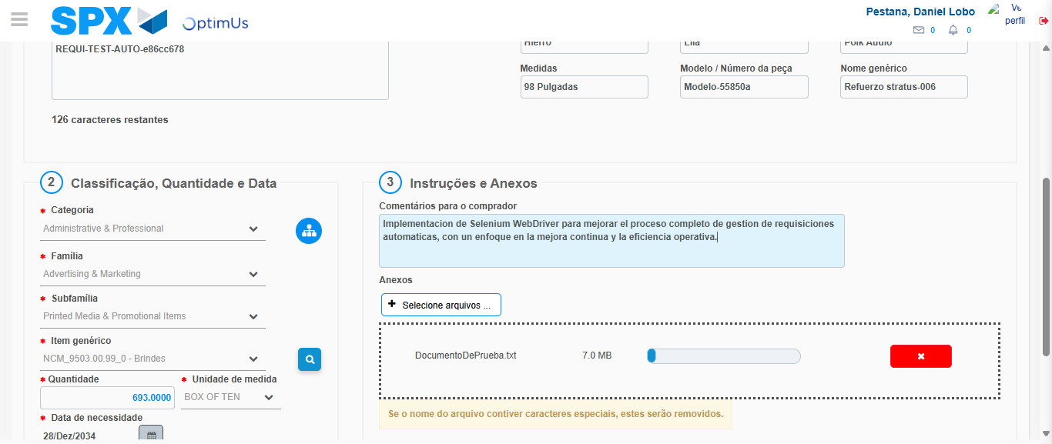Image file-name: QC_Testing-tc006_SPX_Dev5_Crear_Requisicion_Spot_Tipo_Cobro_Proyect_Urgent-1784214857590

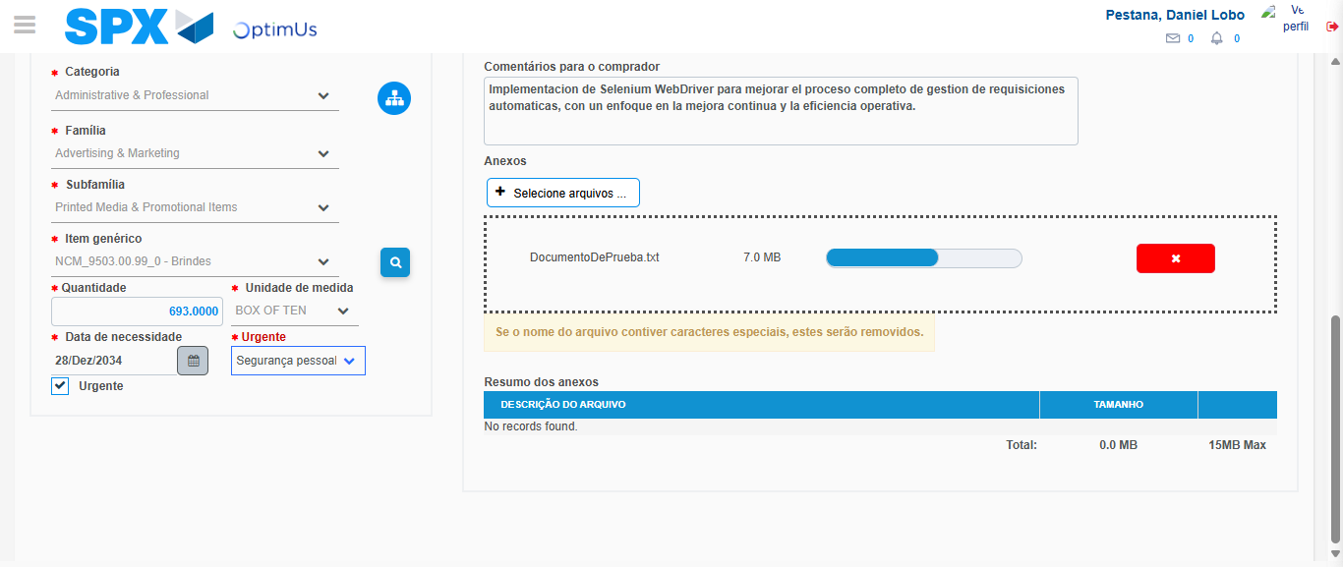Image file-name: QC_Testing-tc006_SPX_Dev5_Crear_Requisicion_Spot_Tipo_Cobro_Proyect_Urgent-1784214861529

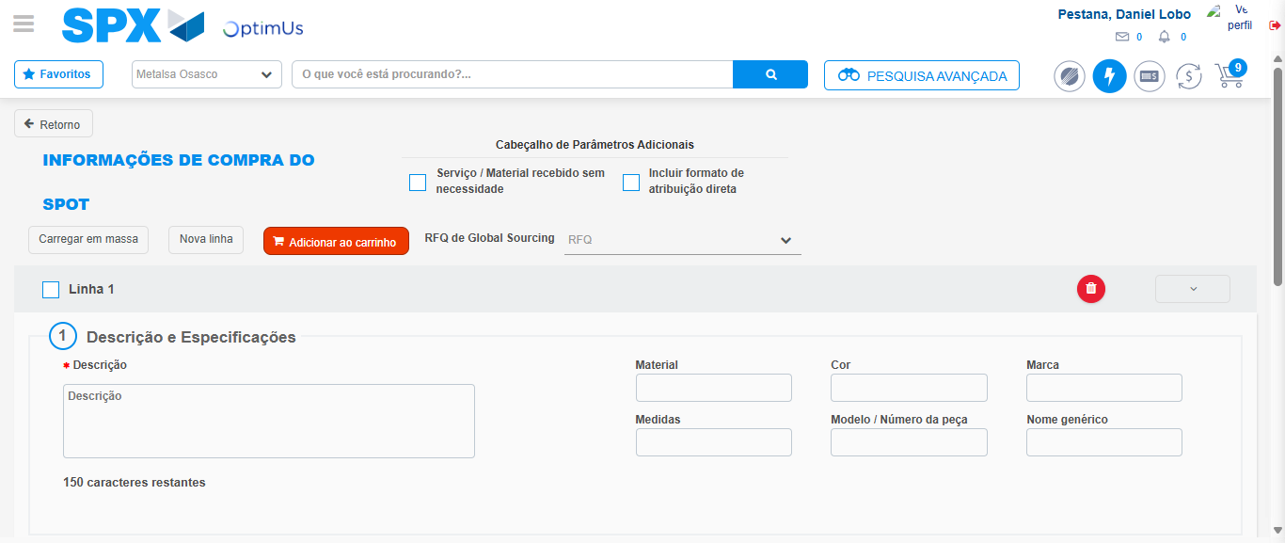Image file-name: QC_Testing-tc006_SPX_Dev5_Crear_Requisicion_Spot_Tipo_Cobro_Proyect_Urgent-1784214866294

Step 7 - Return to Main Page SPX : Return to Main Page SPX
Image file-name: QC_Testing-tc006_SPX_Dev5_Crear_Requisicion_Spot_Tipo_Cobro_Proyect_Urgent-1784214818453

Image file-name: QC_Testing-tc006_SPX_Dev5_Crear_Requisicion_Spot_Tipo_Cobro_Proyect_Urgent-1784214821145

Image file-name: QC_Testing-tc006_SPX_Dev5_Crear_Requisicion_Spot_Tipo_Cobro_Proyect_Urgent-1784214843097

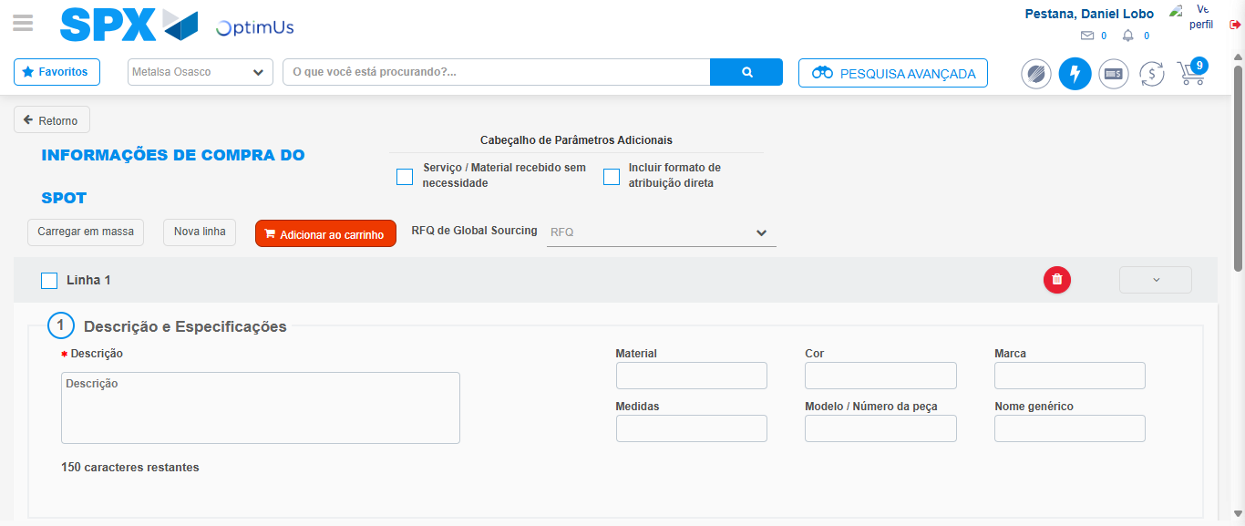Image file-name: QC_Testing-tc006_SPX_Dev5_Crear_Requisicion_Spot_Tipo_Cobro_Proyect_Urgent-1784214868554

Image file-name: QC_Testing-tc006_SPX_Dev5_Crear_Requisicion_Spot_Tipo_Cobro_Proyect_Urgent-1784214868735

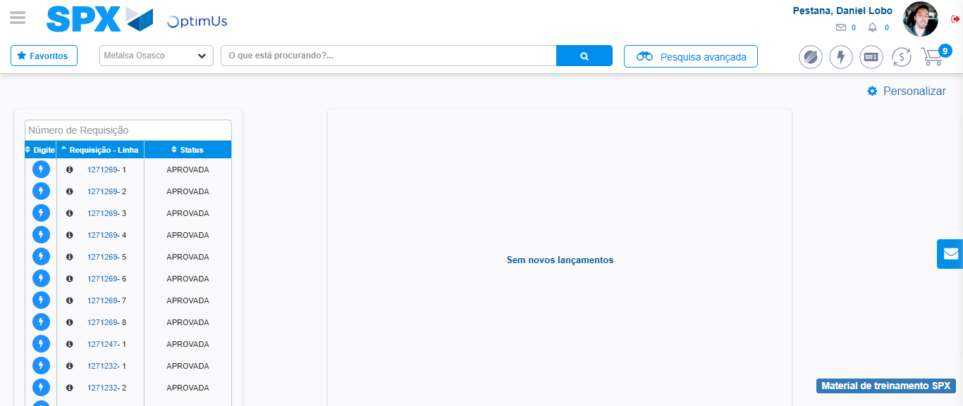Image file-name: QC_Testing-tc006_SPX_Dev5_Crear_Requisicion_Spot_Tipo_Cobro_Proyect_Urgent-1784214889912

Step 8 - Log Out : Log Out SPX
Image file-name: QC_Testing-tc006_SPX_Dev5_Crear_Requisicion_Spot_Tipo_Cobro_Proyect_Urgent-1784214890145

